---------------------------------------------------------------------------------------------------------------------------------------
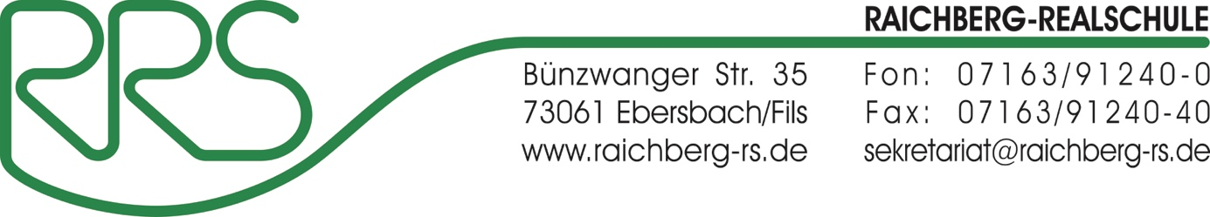

--------------------------------------------------------------------------------------------------------------------------------------
Raichberg-Schulzentrum, Bünzwanger Straße 35, 73061 Ebersbach

Auflösung des Nutzerkontos
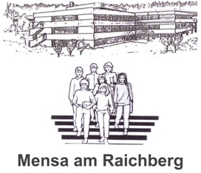
Ausweis-Nr.: Klicken Sie hier, um Text einzugeben.

Nutzer-Name : Klicken Sie hier, um Text einzugeben.

Auflösung des Mensakontos zum
Klicken Sie hier, um ein Datum einzugeben.

☐ Bitte überweisen Sie das Restguthaben von meinem Nutzer-Konto auf folgendes Bank-Konto :

Kontoinhaber : Klicken Sie hier, um Text einzugeben.

Bank : Klicken Sie hier, um Text einzugeben.

IBAN : Klicken Sie hier, um Text einzugeben.

BIC : Klicken Sie hier, um Text einzugeben.

☐ Bitte übertragen Sie das Mensaguthaben auf das Geschwister-Mensa-Konto-Nr. Klicken Sie hier, um Text einzugeben., Name Klicken Sie hier, um Text einzugeben.

Datum : Klicken Sie hier, um ein Datum einzugeben. Unterschrift ______________

